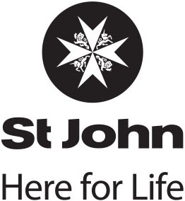
Emergency Ambulance Service Reportable Events: April-June 2019.

Total number of reportable events and near misses
- One closed reportable event was reported to NASO for the period.
- Two SAC two reportable events remain open as at the end of the quarter.

Clinical management events
1

Transport-related events
0

Total events
1

Equipment-related events
0

Other events
0

# | Summary of Reportable Event | Root Cause Analysis | Recommendations | Action Taken
REP890 | The crew did not provide the expected standard level of care during a resuscitation. | The crew did not rotate positions while performing chest compressions at each two-minute cycle, resulting in one officer performing compressions for an extended period of time with the quality of the cardiac compressions regarded as potentially sub-optimal.  The crew failed to recognise the need to prioritise the performance of effective chest compressions over gaining IV access and administering IV drugs. | That the attending personnel be referred to the St John Authority to Practice (ATP) Credentialing Committee for competency review. | Personnel referred to ATP Credentialing Committee.

